The ‘Opening Doors Appeal’
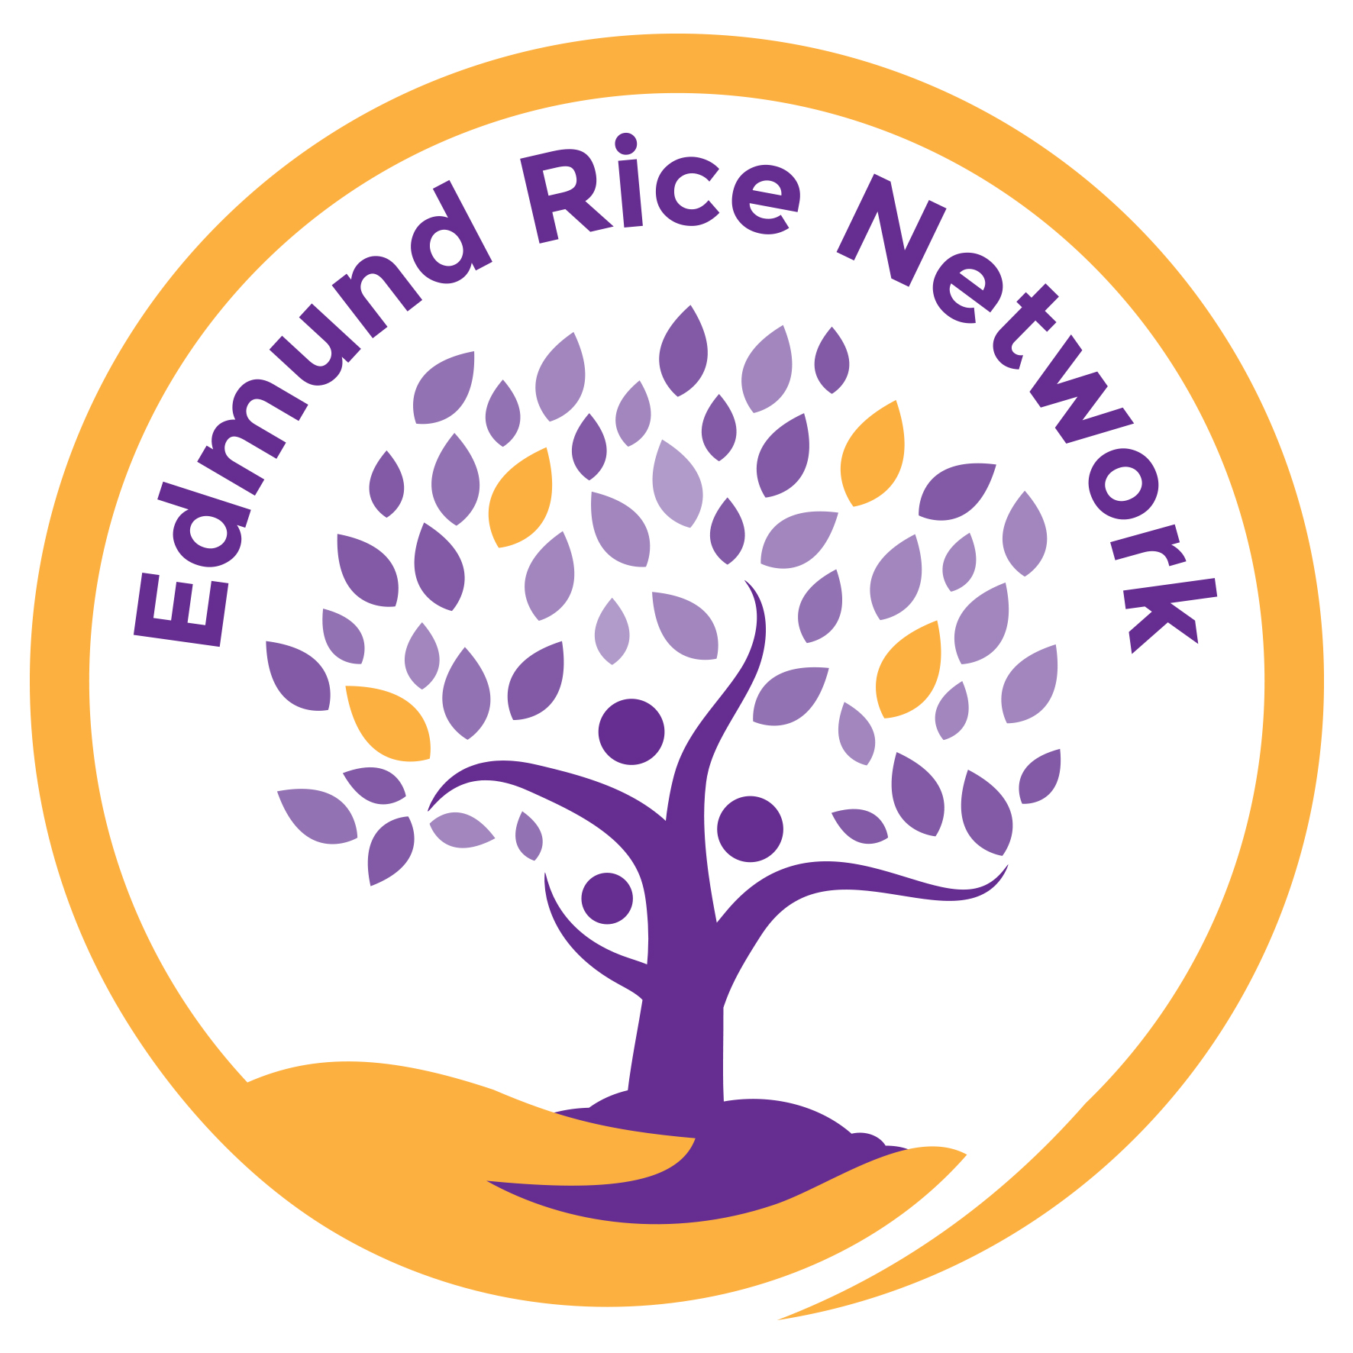

This Christmas we ask that you buy a gift that has truly lasting impact!

The Edmund Rice Schools’ Network is fundraising to build two preschool classrooms in the township of Mamelodi, South Africa. In a vulnerable area such as this, early years provision can truly transform the community by:
- ensuring babies and toddlers are properly nourished
- educating pre-schoolers into the best primary schools
- enabling young (often single) mothers to work and support their families
- providing local employment

You can help!
GET YOUR GIFT CARD FROM SCHOOL
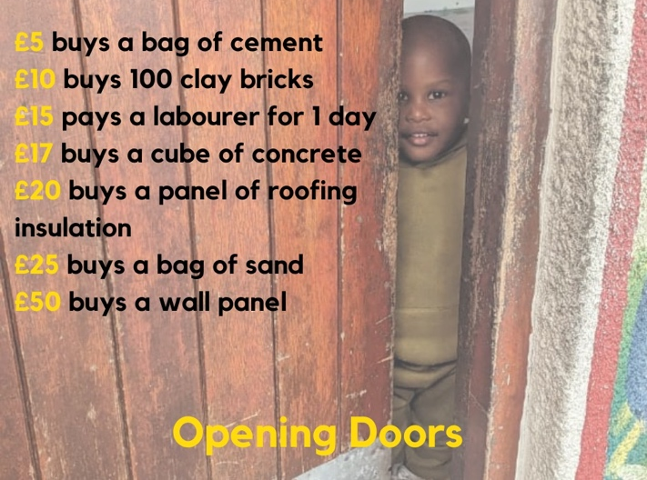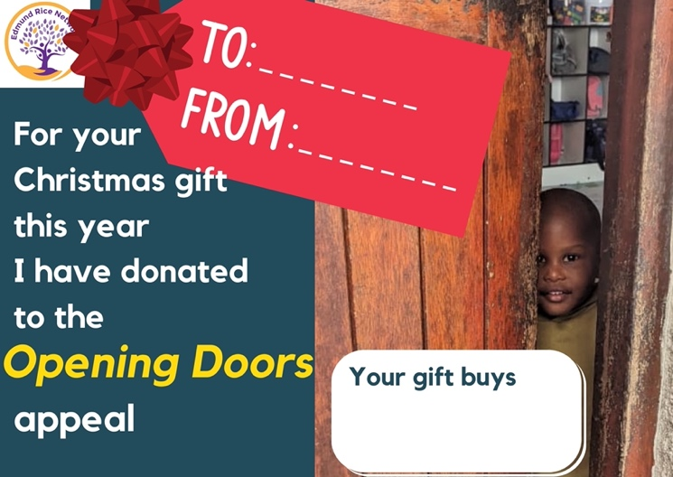
WHAT YOUR DONATION CAN BUY

Do you want to make a real difference this Christmas?
Are you tired of wasting money on buying ‘stuff’ that people don’t really need or want?

This is an opportunity to choose a gift that will have lasting positive impact on a vulnerable
community and to open the door of opportunity for many, many children long into the future.

How?
Choose the amount you want to donate as a gift for a friend or loved one.
Get your gift card from school, fill in your gift details & give it to your recipient.
Transfer the donated amount to:
Account Name: The Congregation of Christian Brothers Account Number: 71273906, Sort Code 40-08-22. REFERENCE Opening Doors (this is very important)

Cards available from

Together we can make a big difference!

